Wixey
ELECTRONIC DIGITAL READOUT

MODEL WR700

INSTRUCTIONS

1- Join the two readout track halves together as shown

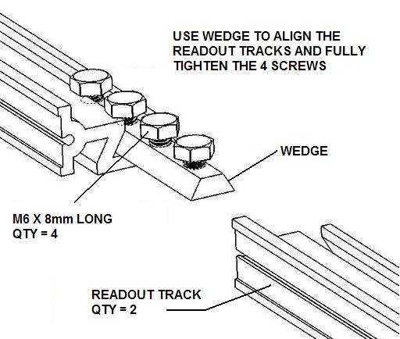
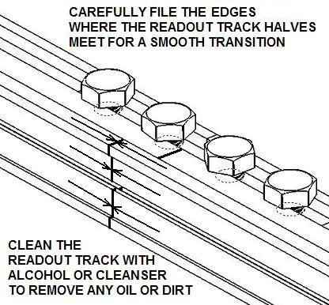

2- Apply the sensor strips to the track as shown

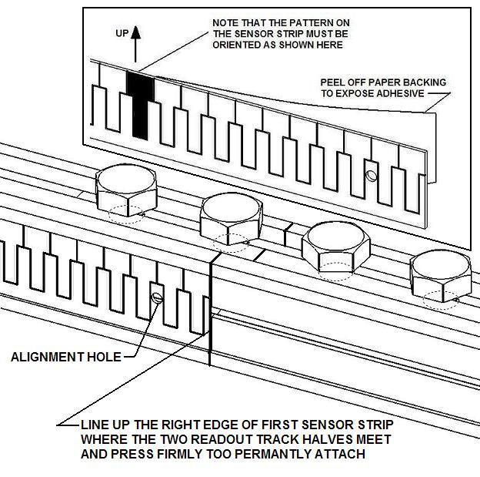
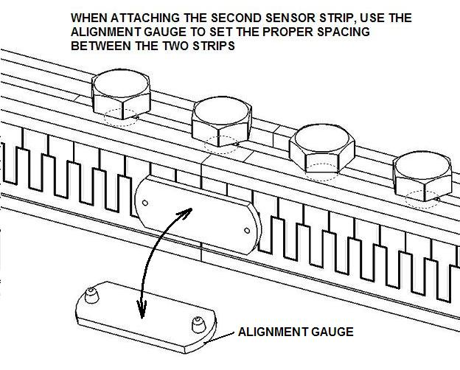

3- Carefully slide the readout onto the readout track

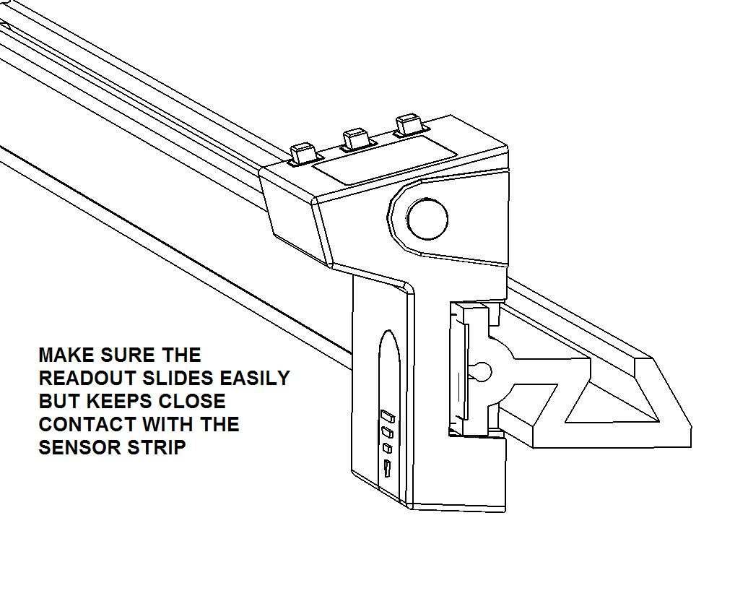
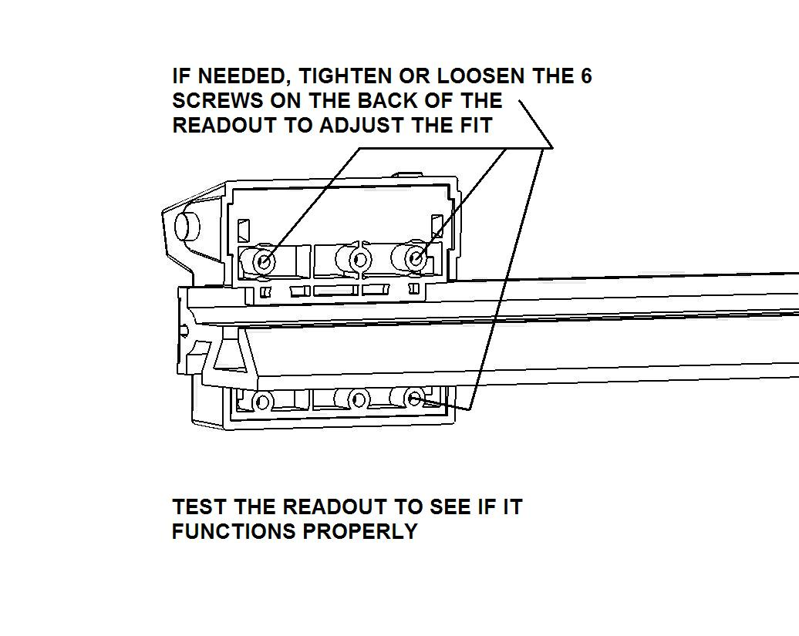

4- Select the readout and readout track mounting location

A. For measuring a full 60” to the right of the blade align the readout track as shown
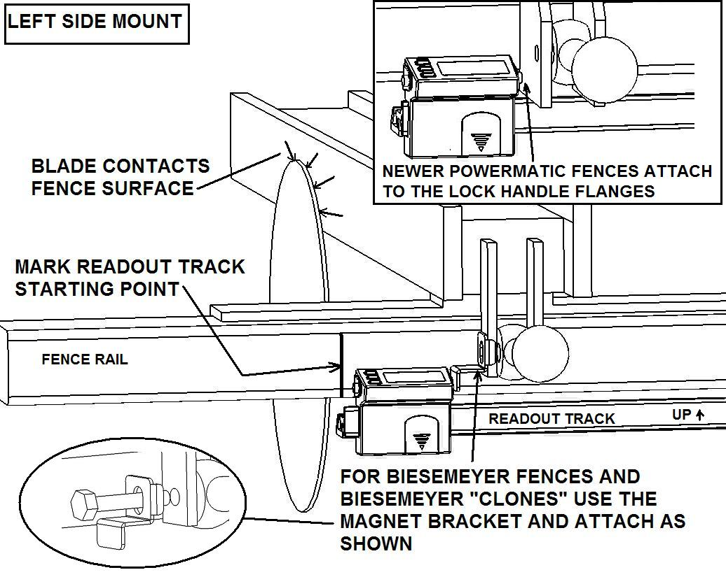

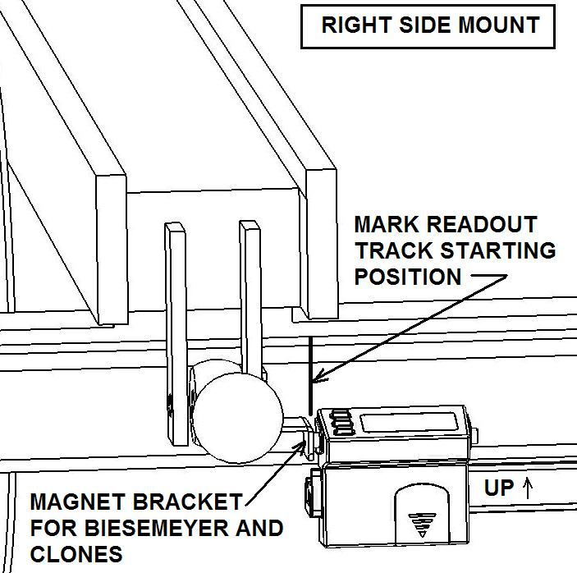

B. For shorter fences or measuring full left of blade and maximum to the right of blade, align the readout track as shown:
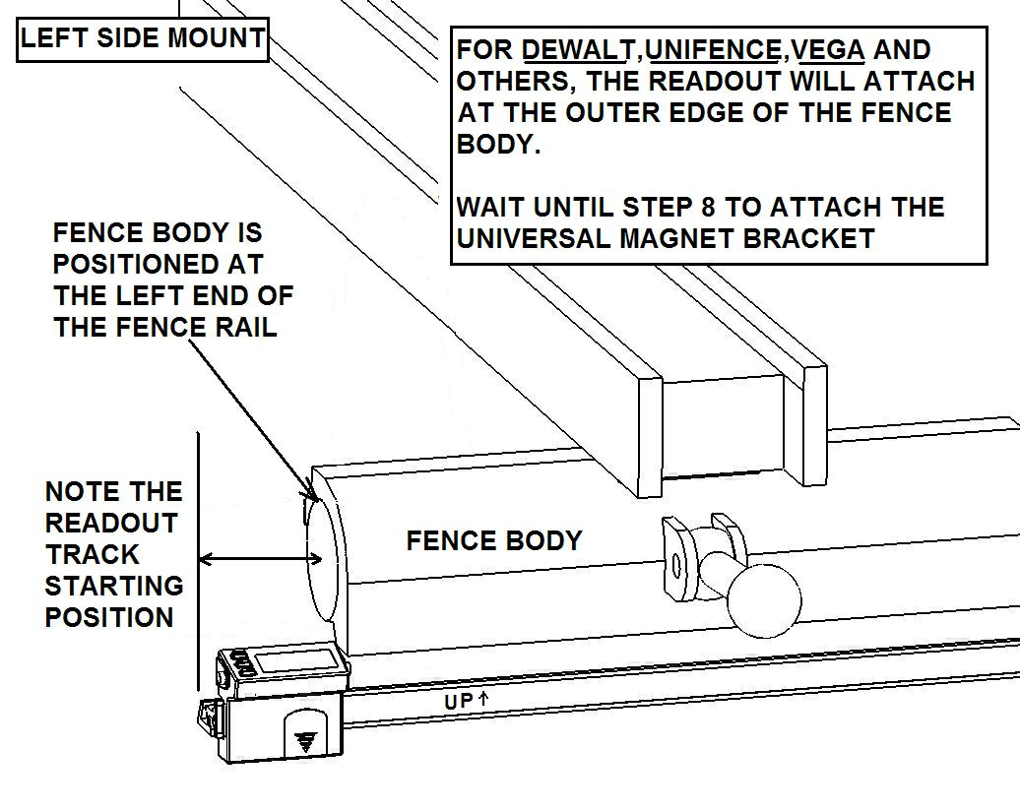

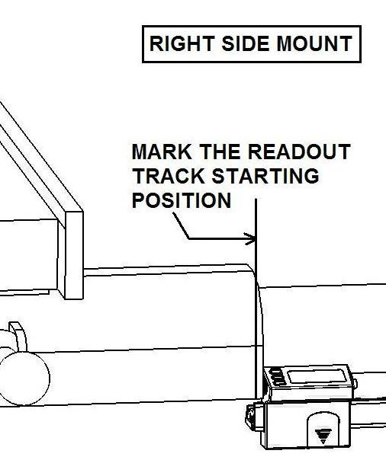

Note: If the readout track is too long it can be cut to length using a hack saw.

5- Attach the track mounting brackets

BEFORE YOU DRILL: Unless you have an actual Biesemeyer T-square fence or a Delta Unifence, it is strongly advised that you that you clamp the readout track assembly with the readout in place onto your saw fence to determine the exact position to drill the holes for the mounting brackets.

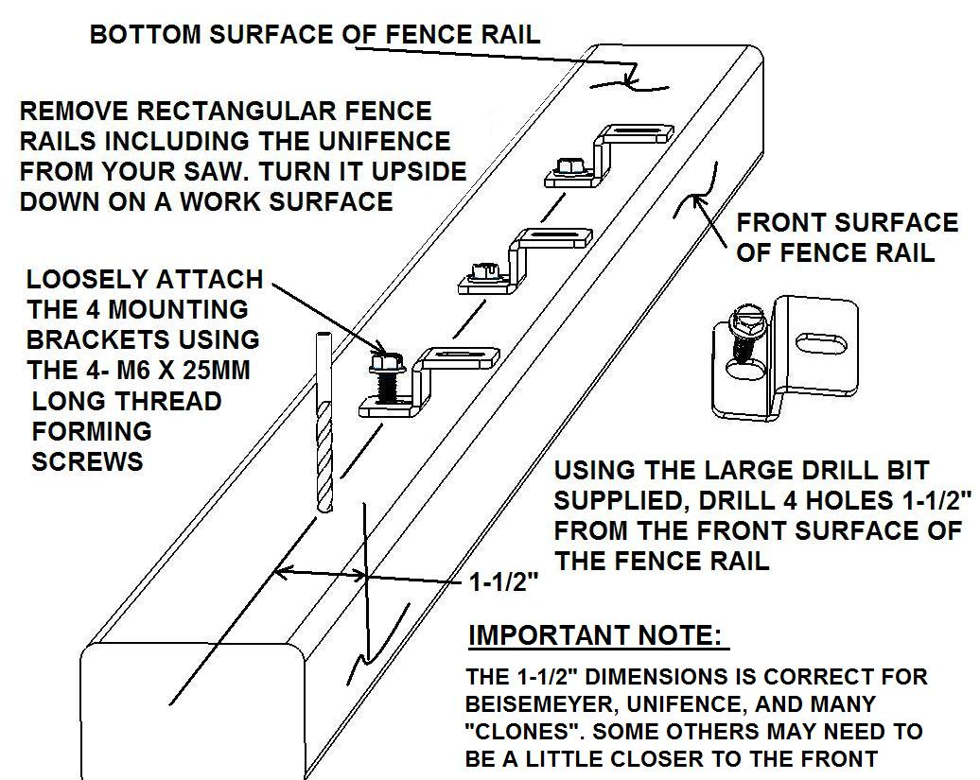
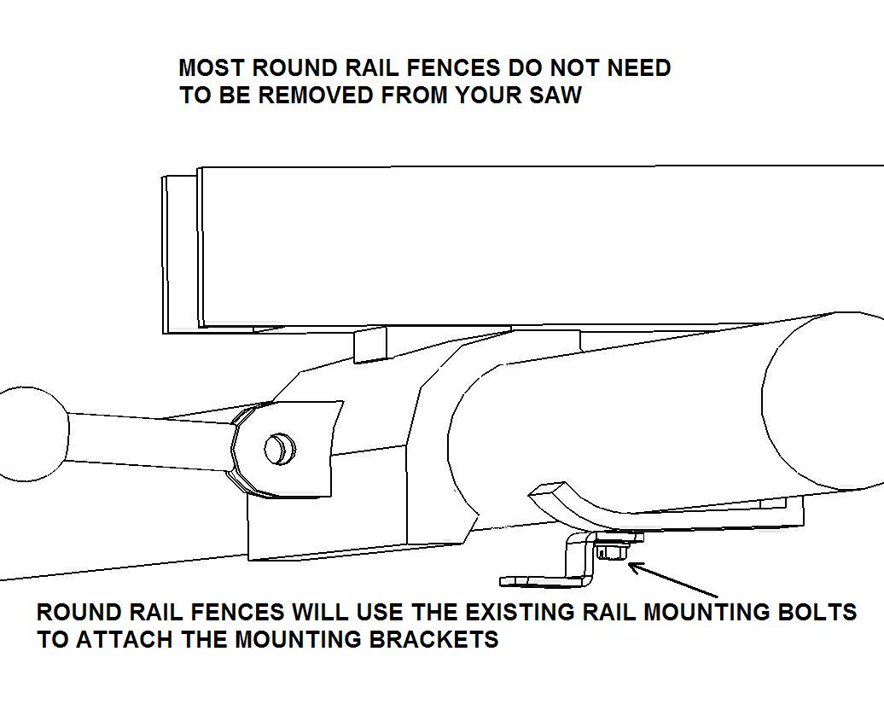

6- Attach the track to the fence rail

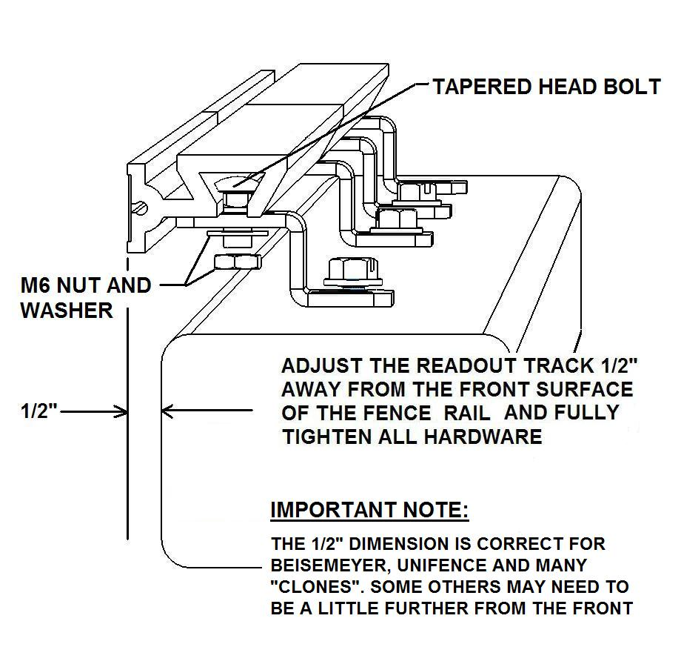

7- Using the universal magnet bracket

- If the standard magnet bracket does not fit your fence body you will need to bend and fabricate one using the universal bracket supplied.

- Use the small drill and one or two of the small self tapping screws to attach the bracket.

For DEWALT and similar fences
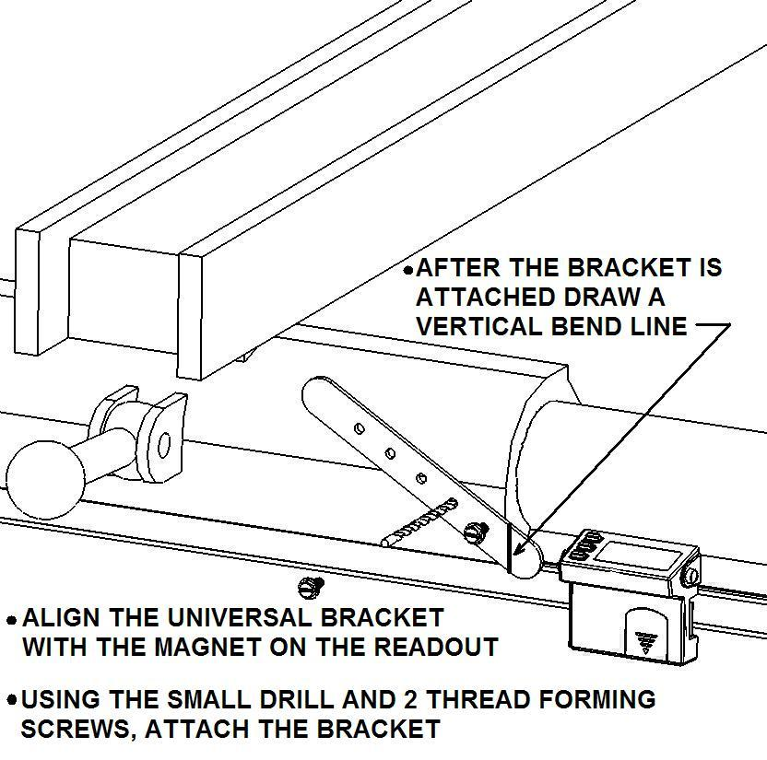
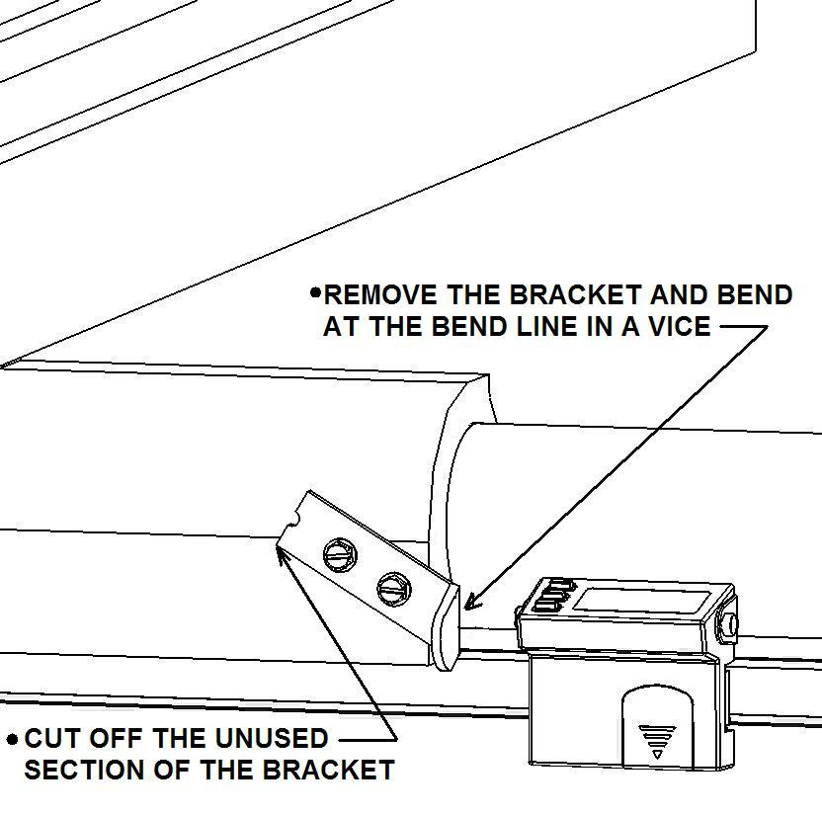

For UNIFENCE and similar fences For VEGA and similar fences
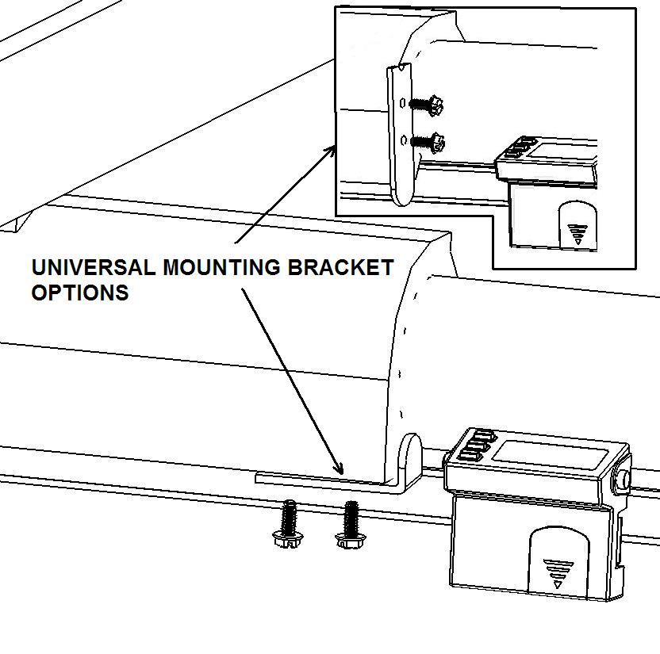
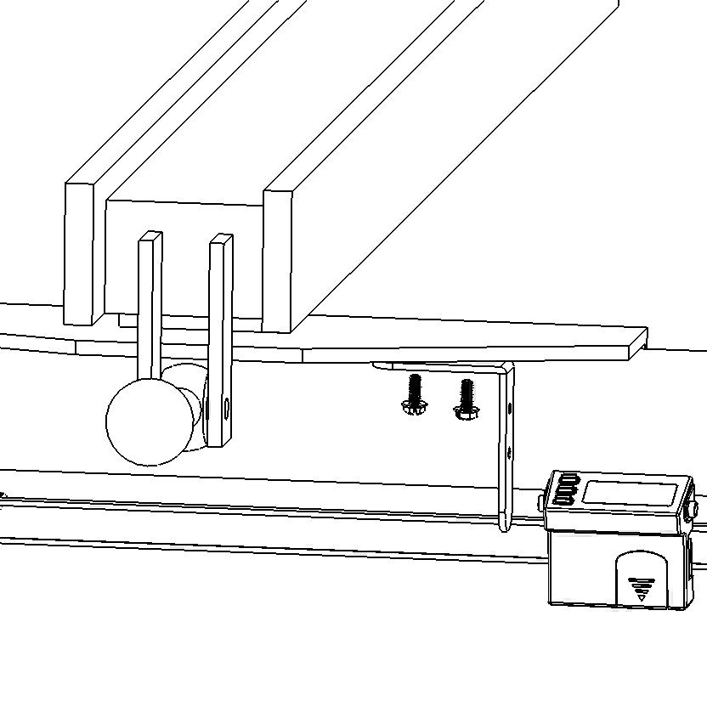

8- Readout operation

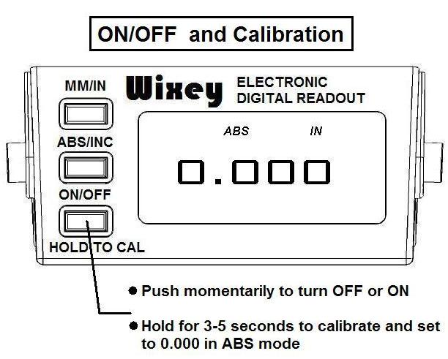

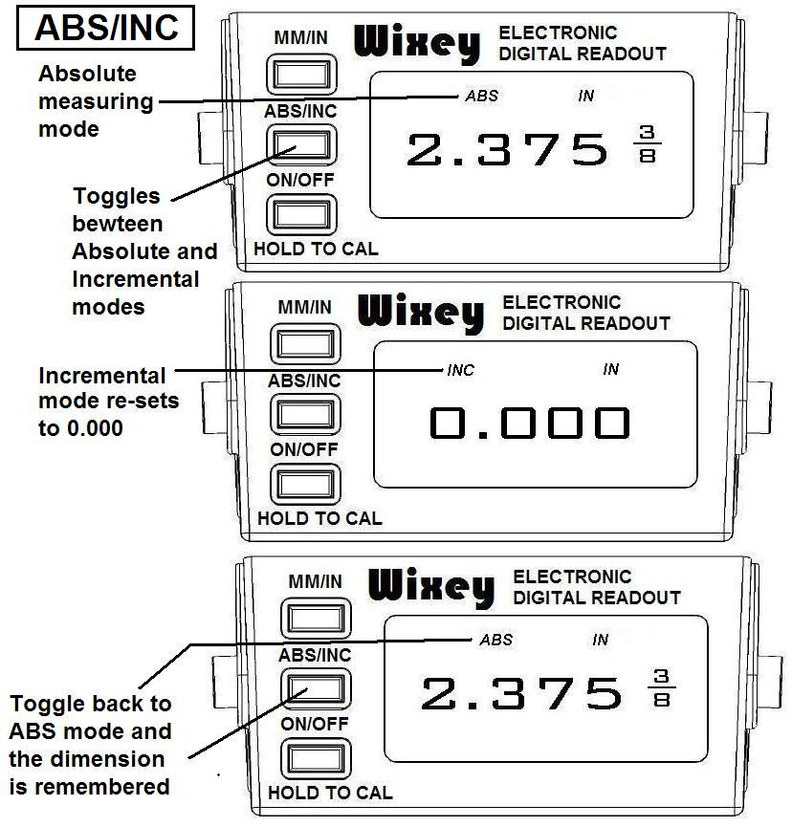

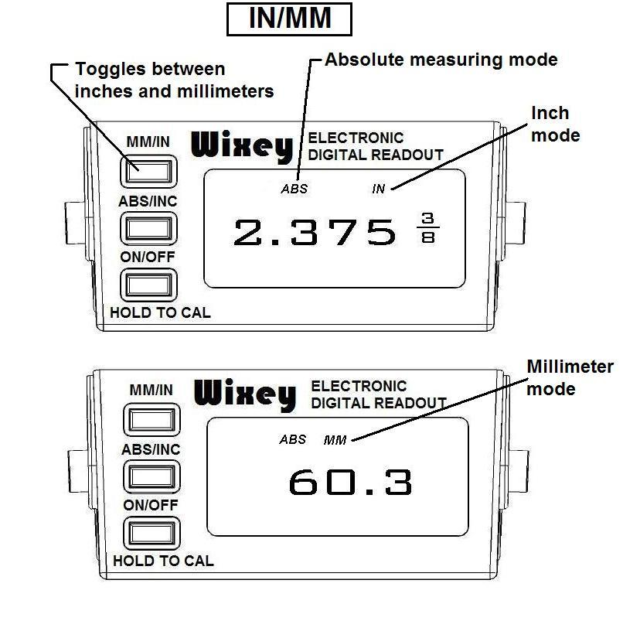

9- Trouble shooting

Problem | Possible Cause | Solution
Flashing Digits | Low Voltage | Replace Battery
No Display | Low Voltage | Replace Battery
No Display | Bad Contact | Clean Battery
Erratic or Frozen Display | Internal Error | Remove Battery Wait 1 Minute and Replace

NOTE: EXTRA BATTERY INCLUDED

6 month battery life. The factory installed battery may be dead when you first receive your readout. Replace battery if the readout does not function properly

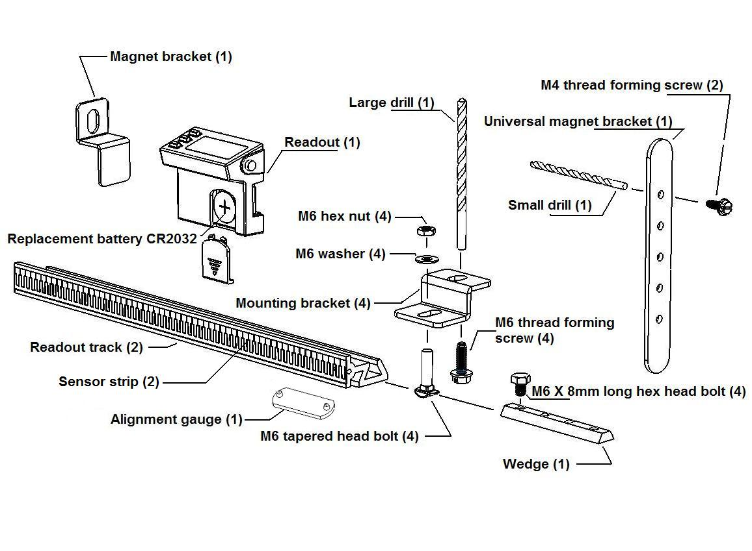

For questions, comments, and application examples go to: www.wixey.com

